

Wiper Mechanism

Submitted By

ABIJITH CB.EN. U4AIE19002

SRIKANTH CB.EN. U4AIE19009

KARTHIK DASARI CB.EN. U4AIE19020

SHANKAR PURAMSETTI CB.EN. U4AIE19049

NITISH SAGALA CB.EN. U4AIE19054

LOGESH CB.EN. U4AIE19073

……………………

For the Completion of

19PHY113-Computational Engineering Mechanics 2

B. Tech 1st year CSE - AI

Table of Contents

Cover page…………………………………………………………………………………………...… i

Brief History and Wiper mechanism …………………………………………………………………. 1

Parts of Wipers and Recent wiper systems …………………………………………………………… 2

Analysis ……………………………………………………………………………………………….. 4

Design Analysis ……………………………………………………………………………………… 7

Matlab Code ………………………………………………………………………………………….. 9

Simulation …………………………………………………………………………………………… 11

Applications …………………………………………………………………………………………. 14

Conclusions ………………………………………………………………………………………….. 15

**Brief history**

In 1903, a patent named “window cleaning device” was awarded to Mary Anderson. Her invention was inspired with her trip from Alabama to New York City in very sloppy weather. She saw drivers were constantly stopping their cars and cleaning their windshields.

The device consisted of a lever, which had to be operated manually from inside of the car and a spring-loaded arm with a rubber blade. It became standard equipment of cars by 1913.

* The revolution in wind shield wipers was caused by Robert Kearns of Detroit and his “Windshield wiper system with intermittent operation”, from 1964.
* He developed a system that controls wiping cycles in response to real condition of the windshield. It was achieved by the fact, that wiper blades produce significantly more friction in dry conditions (e.g. light rain), than in wet conditions (e.g. heavy rain).
* The electric motor is deenergized near end of the cycle and based on conditions, continues in rotation by a small angle due to the momentum of the system. Based on a size of that angle, condition of windshield can be determined.
* When the windshield is very wet, motor is re-energized before the wipers stop completely, which provides continuous operation. On the other hand, dry windshield causes stopping of the wipers and start of dwell period of a creating time.
* 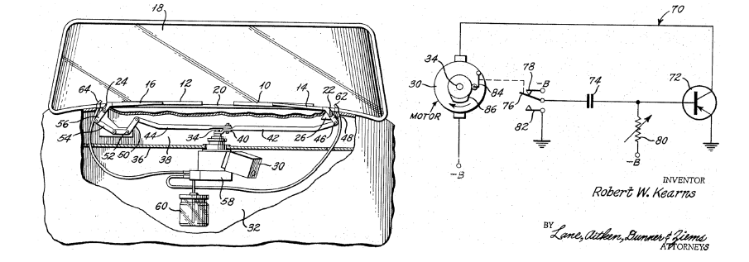

**Wiper Mechanism**

Most of the car wipers work on an inversion mechanism of Basic 4-Bar mechanism, which is very analogous to Beam Engine mechanism.

A windshield wiper is a device designed to remove rain, snow, ice, dirt or debris from a windshield. It is an essential device of nearly every motor vehicle with a cabin.

Cars usually come with two wipers in the front. Arms of windshield wipers are driven through a mechanism hidden under its front hood. A purpose of the mechanism is to transfer rotation of the drive shaft to swing-like motion of wipers.

**Parts of Wipers**

* Motion of the mechanism is provided by an electric motor [1] and gearbox [7] , which transfers torque to a crank [9] . The crank is tightened to shaft with hex nut. Its rotation is transferred by a short conrod (connecting rod) [6] to the driver’s lever [8] and from there to passenger’s lever [4] by a long conrod [5] . Motor with gearbox is mounted on a bracket [3] . Whole assembly is fixed to car’s chassis trough housings [10] and [11] which are connected by a connecting tube [2] .

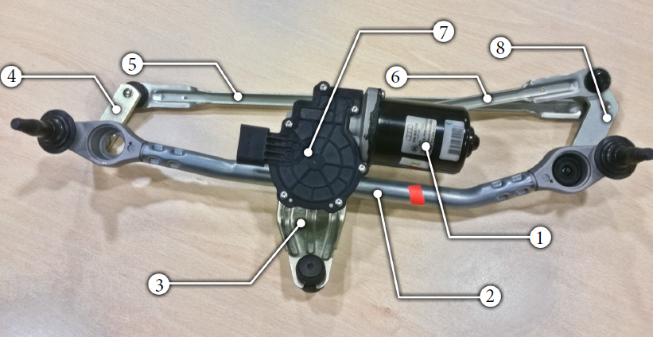

**Recent Wiper Systems**

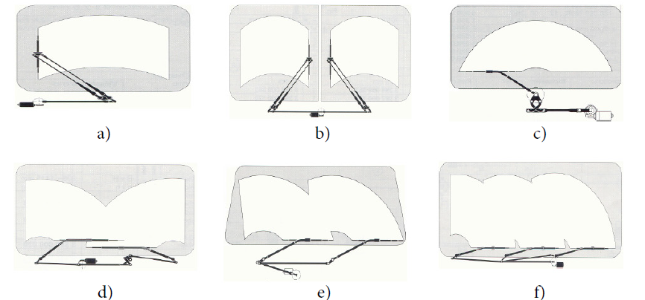

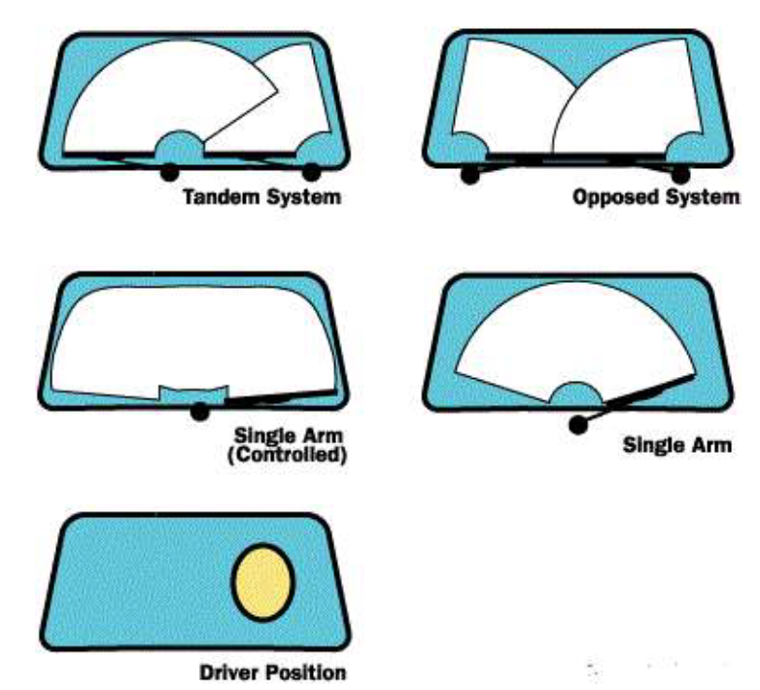

**ANALYSIS**

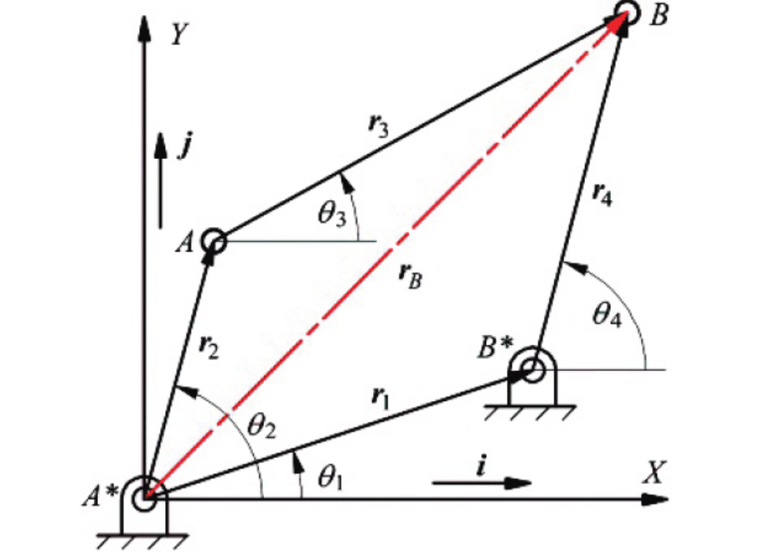







The base vector  will be a constant. If the crank is the driver

then will be given. We need to find other angles



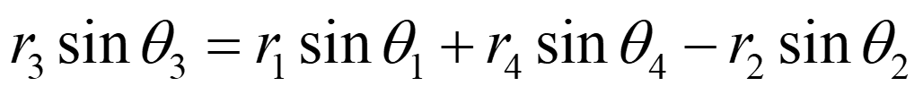







  











**Velocity Equations**

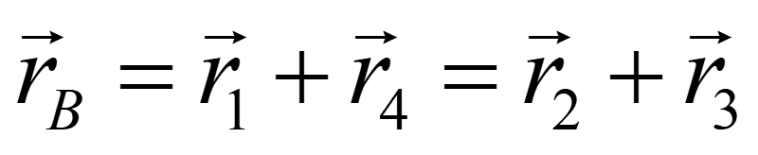









**Acceleration Equations**









**DESIGN ANALYSIS**

FGBD is crank-rocker mechanism.

Here we extend the rocker (BD) to (BE) .

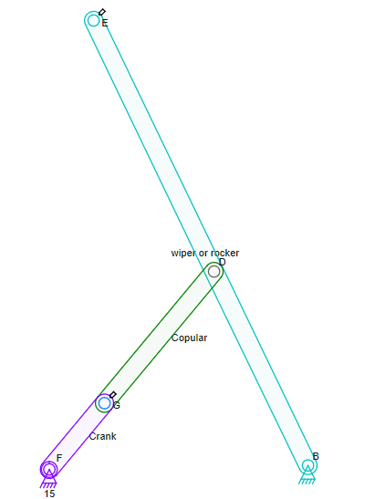

We are adding a parallel rod (BJ) to the wiper with help of the connecting rod (FK) .

Here CFKB act as double rocker

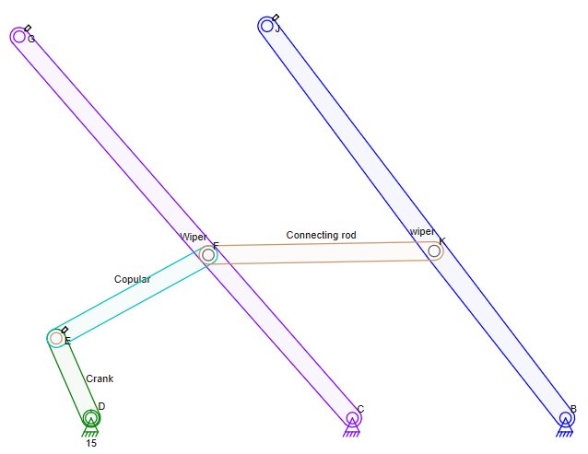

Here both wipers have same

* Velocities at ***G***, ***J***, ***F***, ***K***, ***C***, ***B***.
* Accelerations at ***G***, ***J***, ***F***, ***K***, ***C***, ***B***.
* Angular velocity of ***(CG)*** & ***(BJ)***.
* Angular acceleration of ***(CG)*** & ***(BJ)***.

Here the position difference ***G*** and ***J*** is (in X-axis) length of connecting rod.

**MATLAB CODE:**

clc;

clear;

close all;

r1=input('Length of Link 1(Fixed Link):');

r2=input('Length of Link 2(Crank):');

r3=input('Length of Link 3(Copular):');

r4=input('Length of Link 4(Rocker):');

t1=input('Enter theta 1:'); % angle between fixed link and ground

t1=pi/180*t1;

t2=input('Enter theta 2:'); % angle between r1 and r2

t2=pi/180*t2;

t2dot=input('Enter theta2 dot:');

t2ddot=input('Enter theta2 double dot:');

A=2*r1*r4*cos(t1)-2*r2*r4*cos(t2);

B=2*r1*r4*sin(t1)-2*r2*r4*sin(t2);

C=r1^2+r2^2+r4^2-r3^2-2*r1*r2*(cos(t1)*cos(t2)+sin(t1)*sin(t2));

p=[C-A 2*B A+C];

q=roots(p);

T1=q(1,1);

T2=q(2,1);

choice=input('Roots taken Case(1 or 2):');

if(choice ==1)

disp('roots case 1')

t4=atan(T1)*2;

t4=180/pi*t4;

if(t4 < 0)

t4=180+t4;

end

t4

t3=180/pi*atan((r1*sin(t1)+r4*sin(t4)-r2*sin(t2))/(r1*cos(t1)+r4*cos(t4)-r2*cos(t2)));

if(t3 < 0)

t3=180+t3;

end

t3

Av=[r4*cos(t4) -r3*cos(t3);-r4*sin(t4) r3*sin(t3)];

Bv=[r2*t2dot*cos(t2);-r2*t2dot*sin(t2)];

xv=Av\Bv;

t4dot=xv(1,1) % theta 4 dot

t3dot=xv(2,1) % theta 3 dot

Aa=Av;

Ba=[r4*t4dot^2*sin(t4)-r2*t2dot^2*sin(t2)+r2*t2ddot*cos(t2)-r3*t3dot^2*sin(t3);

-r4*t4dot^2*cos(t4)-r2*t2dot^2*cos(t2)-r2*t2ddot*sin(t2)-r3*t3dot^2*cos(t3)];

xa=Aa\Ba;

t4ddot=xa(1,1) % theta 4 double dot

t3ddot=xa(2,1) % theta 3 double dot

r2dot=[r2*t2dot*cos(t2) r2*t2dot*sin(t2)];

r3dot=[r3*t3dot*cos(t3) r3*t3dot*sin(t3)];

r4dot=[r4*t4dot*cos(t4) r4*t4dot*sin(t4)];

r2ddot=[-r2*t2dot^2*sin(t2) r2*t2ddot*cos(t2)];

r3ddot=[-r3*t3dot^2*sin(t3) r3*t3ddot*cos(t3)];

r4ddot=[-r4*t4dot^2*sin(t4) r4*t4ddot*cos(t4)];

elseif(choice ==2)

disp('roots case 2')

t4=atan(T2)*2;

t4=180/pi*t4;

if(t4 < 0)

t4=180+t4;

end

t4

t3=180/pi*atan((r1*sin(t1)+r4*sin(t4)-r2*sin(t2))/(r1*cos(t1)+r4*cos(t4)-r2*cos(t2)));

if(t3 < 0)

t3=180+t3;

end

t3

Av=[r4*cos(t4) -r3*cos(t3);-r4*sin(t4) r3*sin(t3)];

Bv=[r2*t2dot*cos(t2);-r2*t2dot*sin(t2)];

xv=Av\Bv;

t4dot=xv(1,1)

t3dot=xv(2,1)

Aa=Av;

Ba=[r4*t4dot^2*sin(t4)-r2*t2dot^2*sin(t2)+r2*t2ddot*cos(t2)-r3*t3dot^2*sin(t3);-r4*t4dot^2*cos(t4)-r2*t2dot^2*cos(t2)-r2*t2ddot*sin(t2)-r3*t3dot^2*cos(t3)];

xa=Aa\Ba;

t4ddot=xa(1,1)

t3ddot=xa(2,1)

r2dot=[r2*t2dot*cos(t2) -r2*t2dot*sin(t2)];

r3dot=[r3*t3dot*cos(t3) r3*t3dot*sin(t3)];

r4dot=[r4*t4dot*cos(t4) r4*t4dot*sin(t4)];

r2ddot=[-r2*t2dot^2*sin(t2) r2*t2ddot*cos(t2)];

r3ddot=[-r3*t3dot^2*sin(t3) r3*t3ddot*cos(t3)];

r4ddot=[-r4*t4dot^2*sin(t4) r4*t4ddot*cos(t4)];

end

Lw=input('length of wiper : ');

lw=[Lw*cos(t4) Lw*sin(t4) 0];

t_4dot=[0 0 t4dot];

Vw=cross(t_4dot,lw)

**SIMULATION:**

# **SINGLE WIPER MACHANISM**

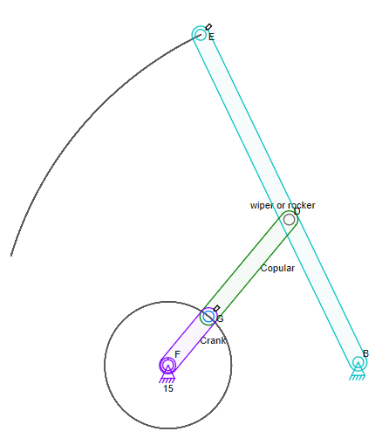

**Here, BE is the wiper arm**

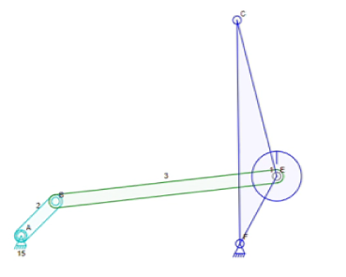

**Here, CE is the wiper arm**

**DOUBLE WIPER MECHANISAM**

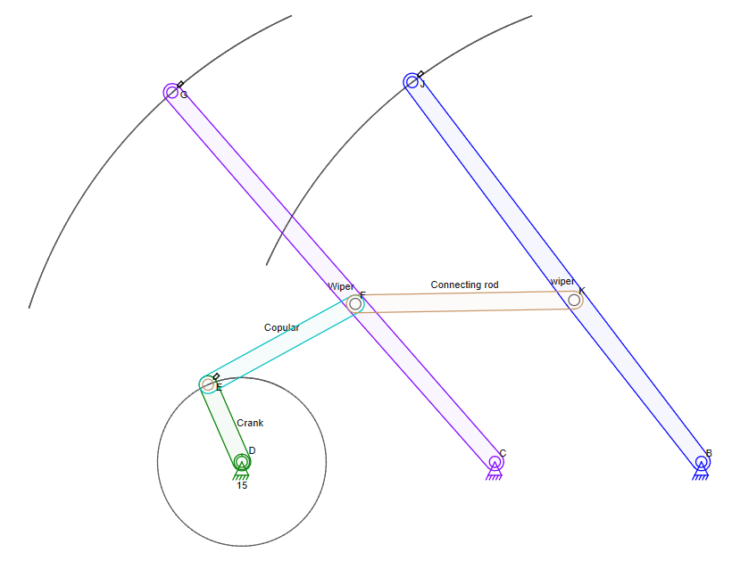

**Here, GC and IA are the wiper arms**

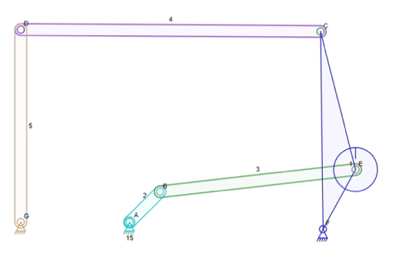

**Here, CE and DG are the wiper arms**

# DOUBLE WIPER (REAL LIFE )

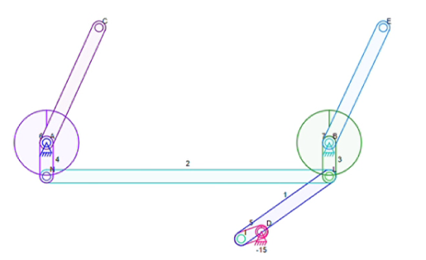

**Here, CA and EB are the wiper arms**

Here the real wife wiper is a compound mechanism which is difficult to analyse position, velocity and acceleration so we are analysing the above single wiper to find position velocity and acceleration.

**Application-(Rain-sensing Wipers)**

In the past, automakers have tried to either eliminate the wipers or to control their speed automatically. Some of the schemes involved detecting the vibrations caused by individual raindrops hitting the windshield, applying special coatings that did not allow drops to form, or even ultrasonically vibrating the windshield to break up the droplets so they don't need to be wiped at all. But these systems were plagued by problems and either never made it to production or was quickly axed because they annoyed more drivers than they pleased. However, a new type of wiper system is starting to appear on cars that actually do a good job of detecting the amount of water on the windshield and controlling the wipers. The sensor projects infrared light into the windshield at a 45-degree angle. If the glass is dry, most of this light is reflected back into the sensor by the front of the windshield. If water droplets are on the glass, they reflect the light in different directions -- the wetter the glass, the less light makes it back into the sensor. The electronics and software in the sensor turn on the wipers when the amount of light reflected onto the sensor decreases to a preset level. The software sets the speed of the wipers based on how fast the moisture builds up between wipes. It can operate the wipers at any speed. The system adjusts the speed as often as necessary to match with the rate of moisture accumulation. The TRW system, which is found on many General Motors cars, including all Cadillac models, can also be overridden or turned off so the car can be washed.

**Conclusion:**

After all results were processed and presented, their credibility should be evaluated. There have been many assumptions needed to be fulfilled, which limit range of their validity. First of all, model of geometry is only approximate – it does not match all the dimensions of original one, that could not be provided. Also, geometry of some parts was very simplified (e.g. shafts, studs) and stress evaluation was not performed on them.

Rigid boundary conditions have been defined in mounting hole of each housing. Real mechanism would be mounted to chassis with certain degree of flexibility, provided by silent-blocks. This could lead to slightly lower stress in certain parts.

All input quantities (except crank’s angle of free rotation in parametric analysis) were considered as deterministic despite the fact that some of them are stochastic by their nature. To evaluate confidence intervals of gained results, some of the inputs should be defined.